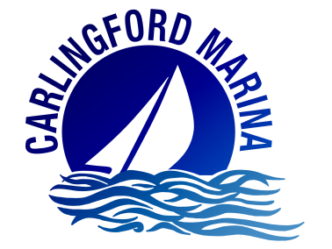
CARLINGFORD MARINE ENTERPRISES LTD.

Carlingford Marina, North Commons, Co Louth, Ireland
042 9373072 – info@carlingfordmarina.ie

Results and Report on the Carlingford Marina Universal Basic Berthage Experiment
August 1st to September 3rd 2018

Introduction
For the month of August, Carlingford Marina decided to scrap their price per metre rate for Visiting Boats and instead charge a fixed rate of €25 per boat per night.
Berthage fees at marinas are normally calculated on a price per metre basis. The per metre rate is multiplied by the LOA (length overall) of the boat, and the resulting figure is the amount you pay to berth your boat.
For example, the nightly rate at Carlingford Marina is €3.50 per metre. So, for a 7-metre boat, the berthage cost would be €24.50 for the night, and for a 12-metre boat, that price would jump to €42.00 for the night
With a fixed rate of €25 per night; smaller boats would see an increase in the amount they pay for overnight berthage, and larger boats would make a saving. The Marina wanted to discover what effect this universal pricing structure would have on; the amount of visiting boats it has, the length of time these boats stay, revenue generated from visiting berthage, and the projected expenditure in the local economy.
Carlingford Marina has compared the results of their experiment to the same period in 2017 and 2016 - and has also compared the results to the three previous months in the 2018 Summer Season; i.e. May, June and July.

Results and Comparisons
Fig. 1 - NUMBER OF VISITING BOATS
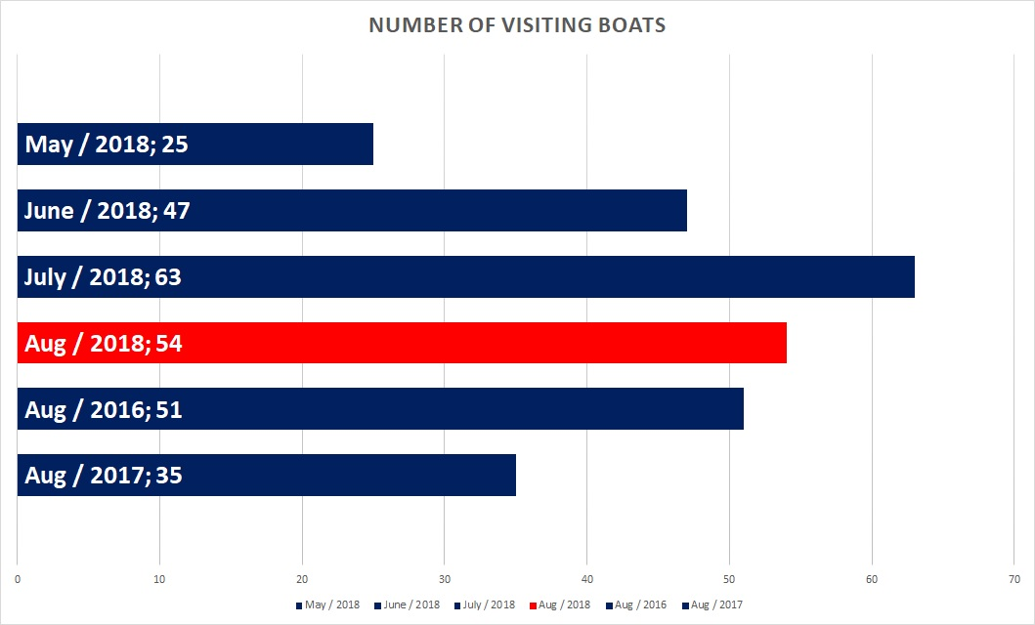
August 2018 - the month of the Universal Basic Berthage experiment - was the second highest performing month this year in terms of visiting boats to Carlingford Marina. After a long winter, the 2018 season got off to a quiet start. The weather had improved in May, but the very cold spring weather prevented boat owners from carrying out the necessary maintenance works to have their boats ready to launch and sail in May.
By the June Bank Holiday weekend, most boats were now ready for the water and visiting numbers increased to normal levels for that time of year. There was an extended period of good weather this summer which led to a very good month for visitors in July.
The weather had normalised again in the middle of July, but visiting numbers remained strong for the month of August. We accredit this to the Universal Basic Berthage Experiment, and partially also to those visitors who had used Carlingford Marina as a stopover port in July making their return trip home in August.
August 2018 was the best August for visiting berthage within the last three years. We accredit this to the Universal Basic Berthage experiment, an improvement in the economy, and to the much better sailing conditions in the 2018 season.
The above trends suggest that the Universal Basic Berthage experiment did encourage more boats to visit Carlingford Marina.

Results and Comparisons
Fig. 2 - NUMBER OF PEOPLE WHO VISITED ON A BOAT
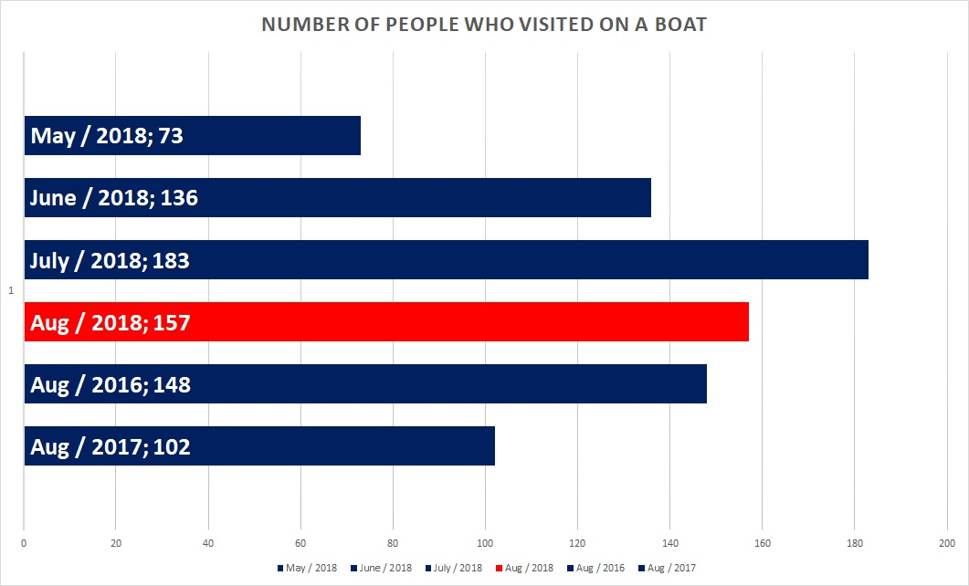
These results correlate as expected with the results in Fig. 1.
August 2018 - the month of the Universal Basic Berthage experiment - was the second highest performing month of all months surveyed.
The above trends do not suggest that the Universal Basic Berthage experiment had any effect on the number of people per boat who visited Carlingford Marina.

Results and Comparisons
Fig. 3 - AVERAGE NUMBER OF NIGHTS THESE BOATS STAYED

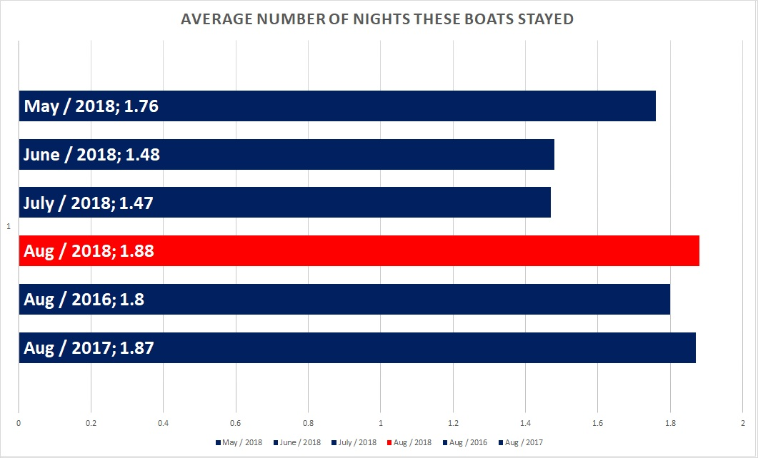
August 2018 - the month of the Universal Basic Berthage experiment - is the highest performing month for average length of time that visiting boats stayed. August is the best performing month, year on year, in this regard.
Visiting boats appear to stay for a longer period of time in May also. This would suggest that a good portion of visitors see Carlingford Marina as a destination port, and the spike in visiting traffic experienced in June and July (reference Fig. 1) is from visitors who use Carlingford Marina as a quick, stopover port.
The above trends do not suggest that the Universal Basic Berthage experiment encouraged visitors to stay at Carlingford Marina any longer than they normally would.

Results and Comparisons
Fig. 4 - TOTAL NUMBER OF VISITOR NIGHTS (PEOPLE)
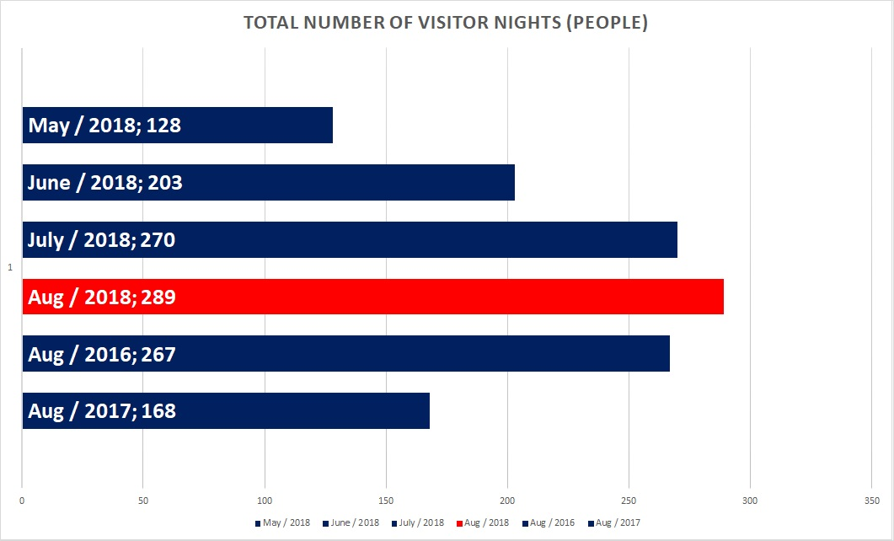
This chart shows how many visitor nights were accounted for in the given time period. I.e. if one person stayed one night, it would account for one visitor nights. And if one person stayed two nights, it would account for two visiting nights.
These results do not correlate as expected with the results in Fig. 1 and Fig. 2. However, when you take the results of Fig. 3 into account; it is evident that visiting boats with more people aboard tend to stay longer.
August 2018 - the month of the Universal Basic Berthage experiment - was the highest performing month of all months surveyed.
Overall, the above trends suggest that the Universal Basic Berthage experiment had a positive effect on the number of visitor nights that Carlingford experienced.

Results and Comparisons
Fig. 5 - AVERAGE BOAT LENGTH (LOA)
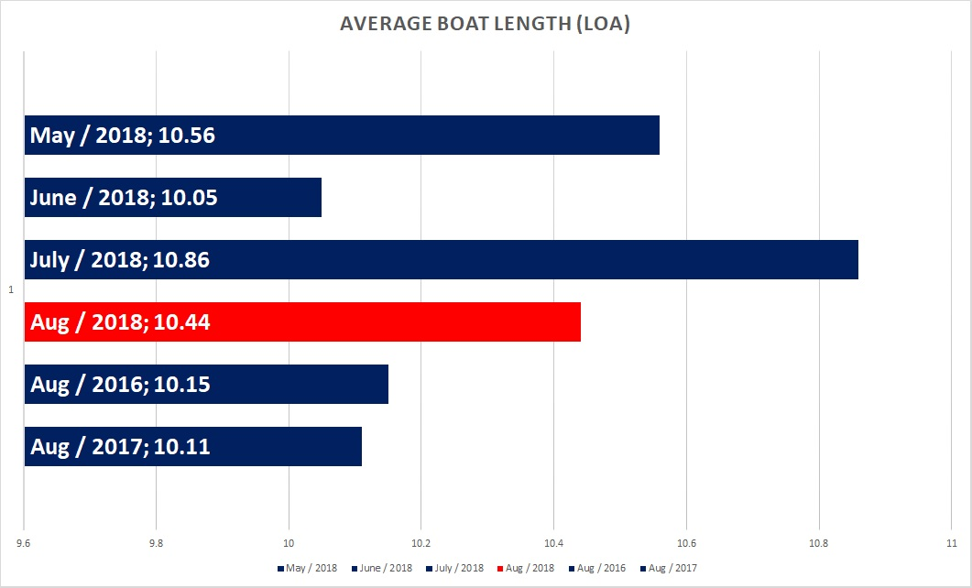
This chart shows the average length of the boats that visited Carlingford Marina in the given time periods. Berthage rates at marinas are usually calculated on a price per metre basis – but the Universal Basic Berthage experiment does away with that pricing structure and instead charges a fixed rate per boat.
With this pricing structure; larger boats stood to make substantial savings in berthage rates – and because of that, we had expected for the average LOA to be higher for the month of the experiment.
As you can see from the graph above; there is notable difference in the average boat length year on year – however, there doesn’t appear to be any pattern emerging from the results.
The above trends do not suggest that the Universal Basic Berthage experiment had an effect on the size of boat visiting Carlingford Marina. However – it may have had an effect on how long the larger boats stayed. The sample recovered in this experiment is not big enough to determine whether or not this is the case.

Results and Comparisons
Fig. 6 - REVENUE GENERATED FROM VISITOR BERTHAGE
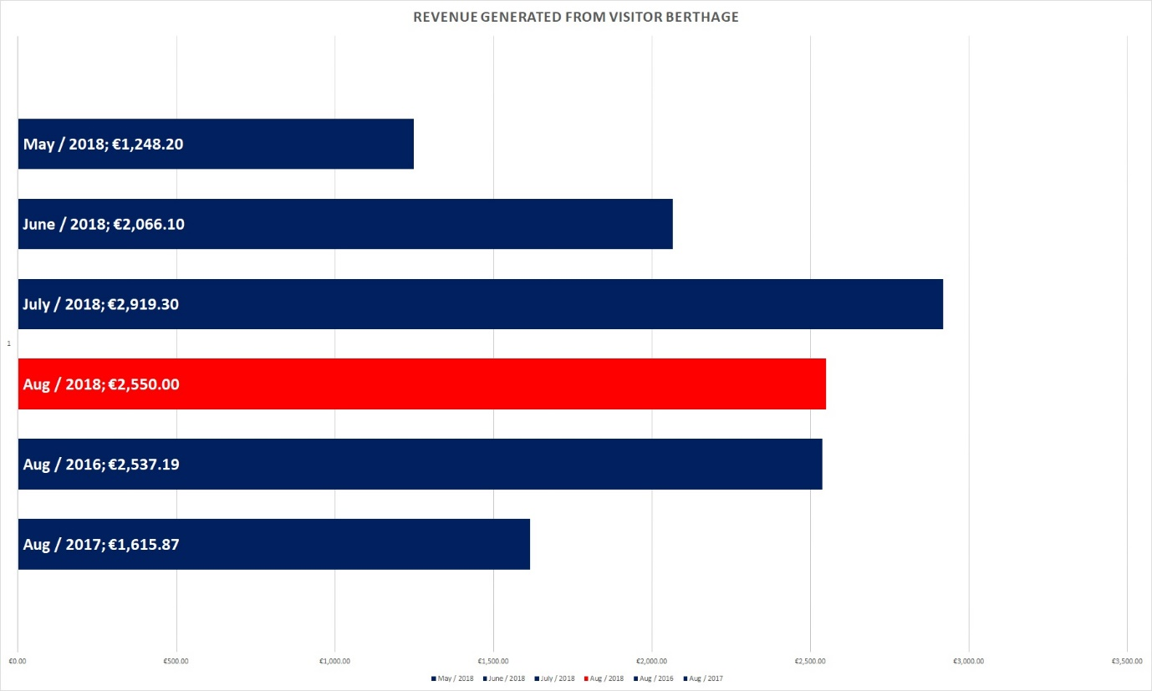
August 2018 – the month of the Universal Basic Berthage Experiment – is the best performing August we have had in the last three years. We accredit this to the Universal Basic Berthage experiment, an improvement in the economy, and to the much better sailing conditions in the 2018 season.
If we had charged our normal rate for visiting boats in this month; revenue would have been €2,887.08. This represents an opportunity cost to Carlingford Marina of €337.08. That being said – we do not believe that we would have gotten the same number of visitors if it were not for this experiment.
We believe that if we were to continue with this pricing structure that revenue from Visitor Berthage would be further reduced. However, the universal pricing structure had an enormously positive effect on customer satisfaction. Unfortunately, we did not have a control to measure customer satisfaction but did manage to collect several testimonials.
“The universal pricing structure is a brilliant idea. It is very fair and reasonable. We know exactly how much it is going to cost us to berth in Carlingford before we arrive, and we know how much it will cost if we decide to stay an extra night. This would be very good to know if ever we got stormbound.”
“We fully support the Universal Basic Berthage Experiment. It is great to see innovation like this from marinas to put their customers first. Perhaps other marinas should follow suit!”
“We visit Carlingford Marina every year, but we heard about this experiment, so we decided to come again this year! We stayed for three nights this time, we normally stay for two.”

Results and Comparisons
Fig. 7 - ESTIMATED EXPENDITURE IN THE LOCAL ECONOMY (LOW ESTIMATE)
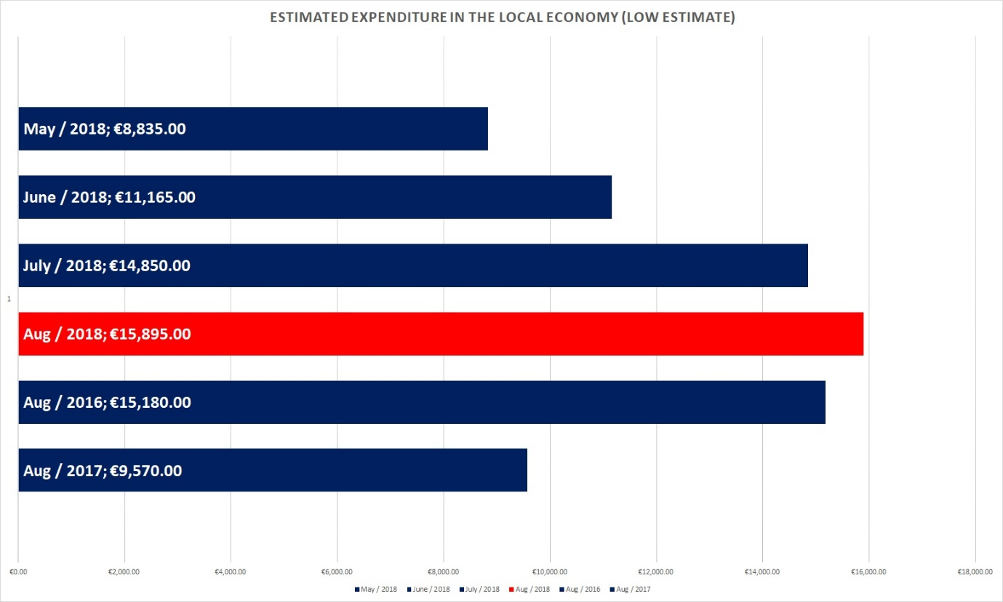
Figures for estimated expenditure were obtained from the Dublin Institute of Technology Carlingford Visitor Survey 2011; “DIT-ACHIEV Project: Achieving Sustainability in Carlingford”. We dismissed costs associated with accommodation; assuming that most or all visitors would be staying on their boats. We did include costs associated with food, drink, shopping, entertainment and miscellaneous.
After you deduct costs associated with accommodation - The low estimate of expenditure for a person visiting Carlingford is €55 per person per day.
August 2018 – the month of the Universal Basic Berthage Experiment – is the best performing month of all months surveyed. This is due to the number of visitors experienced in this month, and the length of time that they stayed in Carlingford - traits that we accredit to the Universal Basic Berthage Experiment.
The boost to the local economy would have been experienced mostly by local cafes, bars and restaurants, but also by taxi companies, grocery shops, fashion and gift shops, entertainment and activity centres, and other miscellaneous spending such as the post office, local barbers, etc.
Carlingford Marina sees this as a very successful result. This is quite a sizeable contribution to the local economy, especially when you consider that this is just one group of visitors to the Marina, for one month of the year.

Results and Comparisons
Fig. 8 - ESTIMATED EXPENDITURE IN THE LOCAL ECONOMY (HIGH ESTIMATE)
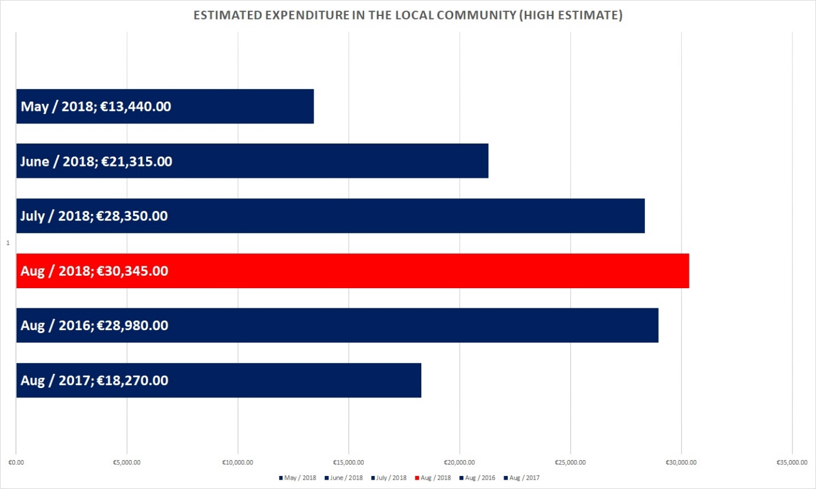
Figures for estimated expenditure were obtained from the Dublin Institute of Technology Carlingford Visitor Survey 2011; “DIT-ACHIEV Project: Achieving Sustainability in Carlingford”. We dismissed costs associated with accommodation; assuming that most or all visitors would be staying on their boats. We did include costs associated with food, drink, shopping, entertainment and miscellaneous.
After you deduct costs associated with accommodation - The low estimate of expenditure for a person visiting Carlingford is €105 per person per day.
August 2018 – the month of the Universal Basic Berthage Experiment – is the best performing month of all months surveyed. This is due to the number of visitors experienced in this month, and the length of time that they stayed in Carlingford - traits that we accredit to the Universal Basic Berthage Experiment.
The boost to the local economy would have been experienced mostly by local cafes, bars and restaurants, but also by taxi companies, grocery shops, fashion and gift shops, entertainment and activity centres, and other miscellaneous spending such as the post office, local barbers, etc.
Carlingford Marina sees this as a very successful result. This is quite a sizeable contribution to the local economy, especially when you consider that this is just one group of visitors to the Marina, for one month of the year.

Conclusion

Overall, we deem the experiment to be a success – but we do have concerns about how these trends will adjust as the novelty of the experiment wears off.
The increase in the Number of Visiting Boats and Total Number of Visitor Nights are very encouraging - and they managed to keep the loss in revenue from Visitor Berthage to a manageable level - but we worry that when visitor numbers normalise, the loss in revenue would be too great to sustain.
There are however other encouraging factors that would combat and outweigh that loss in revenue – namely, customer satisfaction and the estimated expenditure in the local economy. If the customer is happy, we can hope and build towards regular, repeat business with them. We can hope that they tell their friends, and that word starts to spread to new, potential customers. And with an increased footfall; we can look to broaden our own offering and generate income in other ways – for example with a small chandlery, gift shop, bike hire, etc.
We are excited about the opportunities that this could bring, but there are still quite a few “unknowns” that a survey of this size could not predict. For that reason, we have decided to extend the experiment to run through the 2019 Season.

