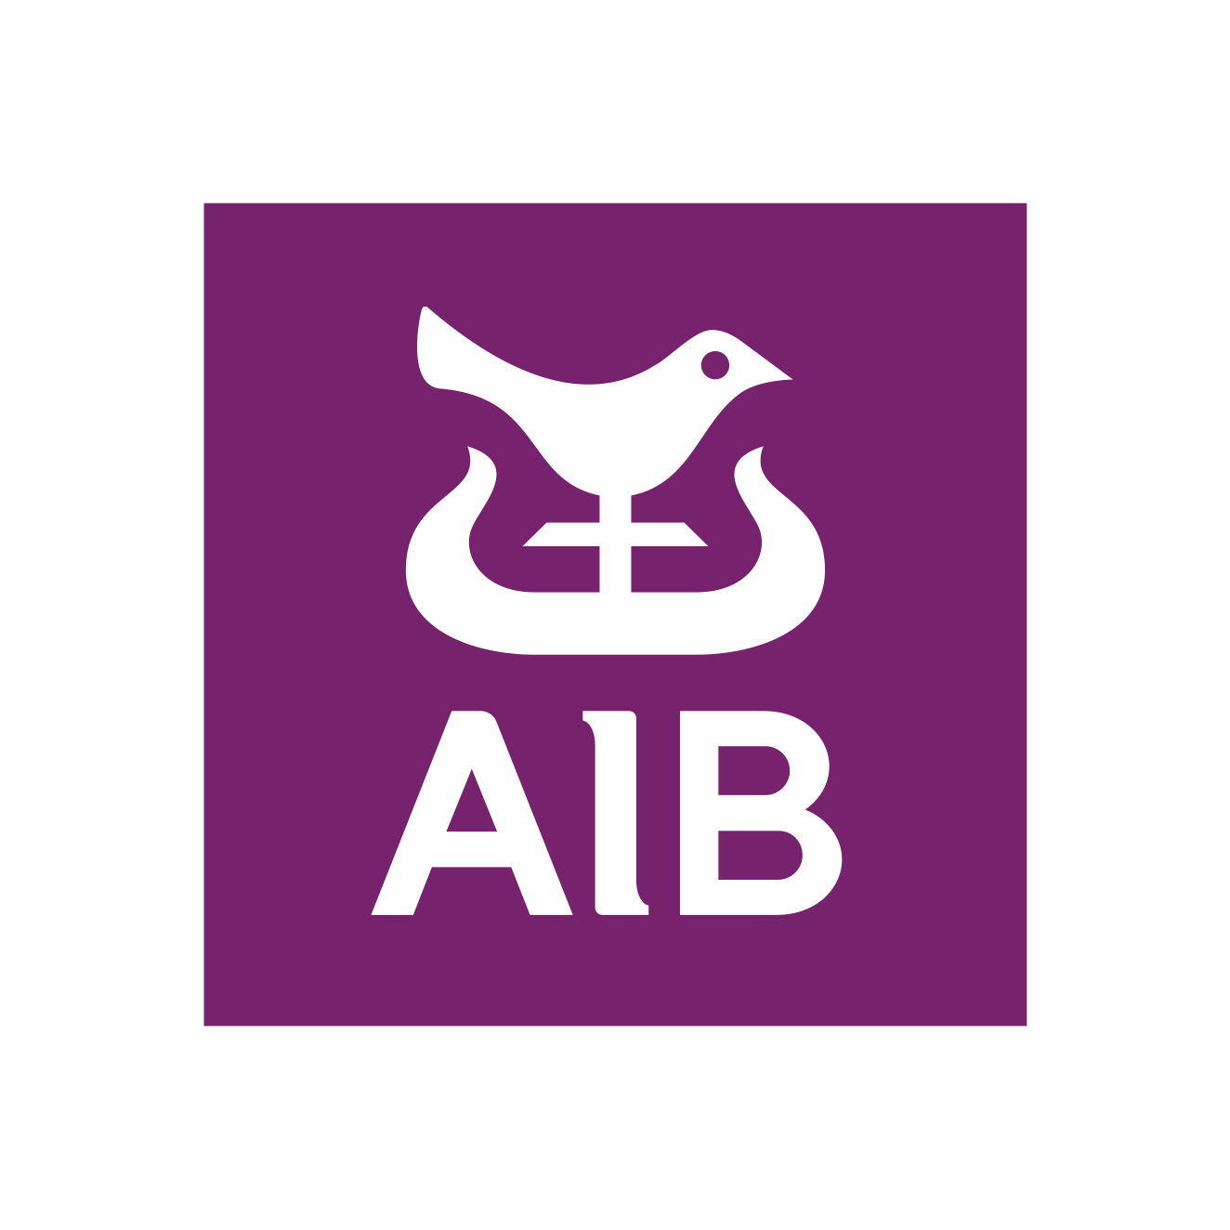

AIB DBSC SPRING CHICKEN SERIES 2023

SUNDAY 5th FEBRUARY – SUNDAY 12th MARCH

NOTICE OF RACE

A series of SIX races to be held on Sunday mornings organised by Dublin Bay Sailing Club. A progressive handicap on a time-on-time basis will be used. For keelboats, cruisers, cruising boats, one-designs and boats that do not normally race are very welcome.

First gun 10.10 hrs.

Entry fee €60.00 – includes temporary membership of Dublin Bay S.C. and National Y.C.

Entries on line at www.dbsc.ie

Any problems with entry, contact Rosemary Roy, Hon. Sec. at 086 8319657
or Fintan Cairns at 087 2439208

Sailing instructions will be available on Sunday 5th February and will be emailed to entrants beforehand.
After sailing - draws, food etc. will be available to competitors in National Y.C. who are kindly hosting the series. You have to be there to win!

Last date for entries – Wednesday 1st February
Handicaps of late entries (and incorrect sail nos.!) will be adjusted accordingly!

